**Lab Assignment-6**

**Indian Institute of Technology Roorkee Department of Computer Science and**

**Engineering**

**CSN-361: Computer Networks Laboratory (Autumn 2019-2020)**

Aman jaiswal

Enrollment No:-17114008

B.tech CSE 3rd Year.

Problem Statement 1:

**Use OPNET to implement OSPF (Open Shortest Path First) protocol. Create a scenario –Scenario1, of 8 routers of any type (e.g., slip8_gtwy) and configure the Network topology and the Link costs as shown in Fig. 1(a) and Fig. 1(b) respectively.Create a duplicate scenario – Scenario2, where the routers in Scenario1 are partitioned into 3different areas Area1: RouterA, RouterB, RouterC Area2: RouterD, RouterEArea3: RouterF, RouterG, RouterH .Display the route for the traffic demand between RouterA and RouterC in Scenario1. Display theroute for the traffic demand between RouterA and RouterC in Scenario2.**

**Data Structure and algorithm:**

* **Slip8_gtwy Router**- The **slip8_gtwy** node model represents an IP-based gateway supporting up to eight serial line interfaces at a selectable data rate. The RIP or OSPF protocols may be used to automatically and dynamically create the gateway’s routing tables and select routes in an adaptive manner.
* **PPP_DS3** **link**- The **PPP_DS3** link has a data rate of 44.736 Mbps.

created 8 routers of type slip8_gtwy.

OSPF protocol is used, Open Shortest Path First (OSPF) is a link-state routing protocol which is used to find the best path between the source and the destination router.

The simulation statistics are made over 10 minutes.

In Scenario2 routers are patitioned as follows:

Area1: RouterA, RouterB, RouterC

Area2: RouterD, RouterE

Area3: RouterF, RouterG, RouterH

Route for the traffic demand between RouterA and RouterC in Scenario1-

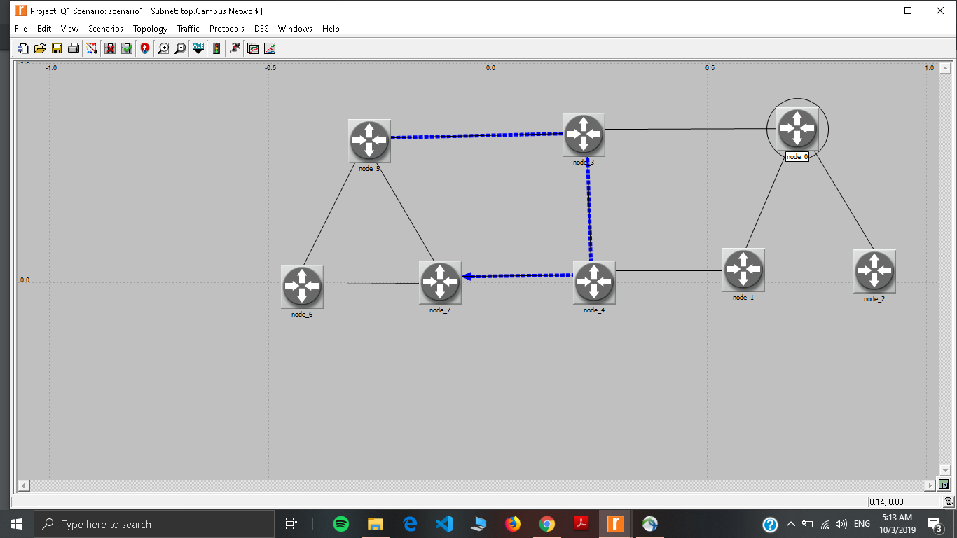

Route for the traffic demand between RouterA and RouterC in Scenario2

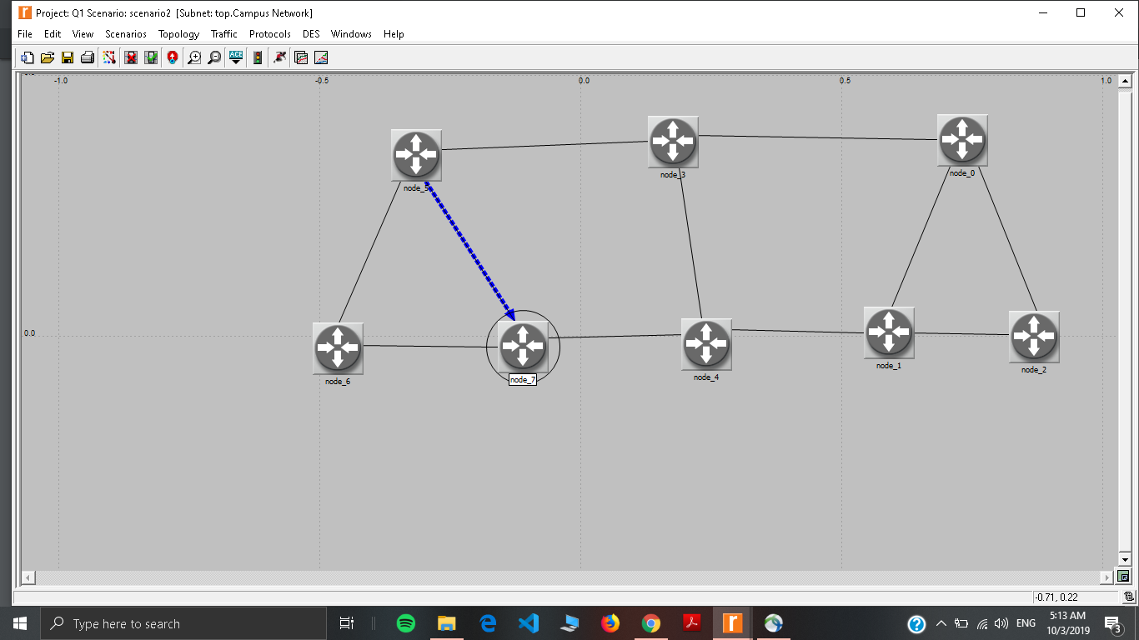

**Problem Statement 2:**

**Use OPNET to implement RIP (Routing Information) protocol on the same network configurations as given in Problem 1. Display the route for the traffic demand between RouterA and RouterC in Scenario1. Display the route for the traffic demand between RouterA and RouterC in Scenario2.**

The Routing Information Protocol is one of the oldest distance-vector routing protocols which employ the hop count as a routing metric. RIP prevents routing loops by implementing a limit on the number of hops allowed in a path from source to destination. In Routing Information Protocol, the cost is the same for all edges. It counts and minimizes the number of hop counts for finding the best path. So, the best path should be the direct link between the routers

**Data Structure and algorithm:**

* **Slip8_gtwy Router**- The **slip8_gtwy** node model represents an IP-based gateway supporting up to eight serial line interfaces at a selectable data rate. The RIP or OSPF protocols may be used to automatically and dynamically create the gateway’s routing tables and select routes in an adaptive manner.
* **PPP_DS3** **link**- The **PPP_DS3** link has a data rate of 44.736 Mbps.

Route for the traffic demand between RouterA and RouterC in Scenario1->

